

**UNIVERSITI TUN HUSSEIN ONN MALAYSIA**

**TEST 1**

**SEMESTER I**

**SESSION 2022/2023**

COURSE NAME : WEB DEVELOPMENT

COURSE CODE : DAT 21303

NAME : QAIREL QAYYUM BIN MUHAMAD RIDHUAN

MATRIC NO : AA212363

SECTION : 6

INSTRUCTION : CONVERT YOUR ANSWERS INTO PDF

FORMAT AND SUBMIT VIA FORM GIVEN.

# **Q1**

**(a)**

**.** **<!DOCTYPE html>**

**<html>**

**<body>**

**<?php**

**// downward triangle pattern**

**echo "***<br>";**

**echo "**<br>";**

**echo "*<br>";**

**echo "**<br>";**

**$size2 = 6;**

**for($i = 0; $i < $size2; $i++) {**

**// print stars**

**for($j = 0; $j < $size2 - $i; $j++) {**

**echo "*";**

**}**

**echo "<br>";**

**}**

**?>**

**</body>**

**</html>**

**(b)**

**.** **<html>**

**<body>**

**<?php**

**$cars = array("Proton", "Produa", "Toyota", "BMW");**

**echo "Cars: ";**

**echo $cars[0] . ", " . $cars[1] . "," . $cars[2] . ",". $cars[3];**

**?>**

**</body>**

**</html>**

**.** **<html>**

**<body>**

**<?php**

**$student = array("Ali ", "Aboo ", "Sarah ");**

**$grade = array("25", "50", "900");**

**echo "Student grades: ";**

**echo $student[0] . " - " . $grade[0] . ", " .$student[1] . " - " . $grade[1] . ", " . $student[2] . " - " . $grade[2];**

**?>**

**</body>**

**</html>**

**.** **<html>**

**<body>**

**<?php**

**$time = array("8:00", "9:00", "10:00", "11:00", "12:00");**

**echo "Bus schedule: ";**

**echo $ time [0] . ", " . $ time [1] . "," . $ time [2] . ",". $ time [3]. ",". $ time [4];**

**?>**

**</body>**

**</html>**

**.** **<html>**

**<body>**

**<?php**

**$intake = array("2017", "2018 ", "2019 ", "2020");**

**$bil = array("300", "350", "450", "500");**

**echo $ intake [0] . " - " . $bil[0] . ", " .$ intake [1] . " - " . $bil[1] . ", " . $ intake [2] . " - " $bil[2] . ", " . $ intake [3] . " - " . $bil[3];**

**?>**

**</body>**

**</html>**

**.** **<html>**

**<body>**

**<?php**

**$sem = array("Semester1", "Semester2", "Semester3", "Semester4");**

**$credit = array("17", "16", "19", "18");**

**echo "Course Credit: ";**

**echo $sem[0] . " - " . $credit[0] . ", " .$sem[1] . " - " . $credit[1] . ", " . $sem[2] . " - " .$credit[2] . ", " . $sem[3] . " - " . $credit[3];**

**?>**

**</body>**

**</html>**

# **Q2**

**i) <!DOCTYPE HTML>**

**<html>**

**<style>**

**.login{**

**background-color:#008000;**

**height:25px;**

**width:170px**

**}**

**</style>**

**<body>**

**<form>**

**Username : <input type="text" name="Uname" style="background-color:#ADD8E6"><br><br>**

**Password : <input type="text" name="password" style="background-color:#ADD8E6"><br><br>**

**<button type="button" class="login">Login</button>**

**</form>**

**</body>**

**</html>**

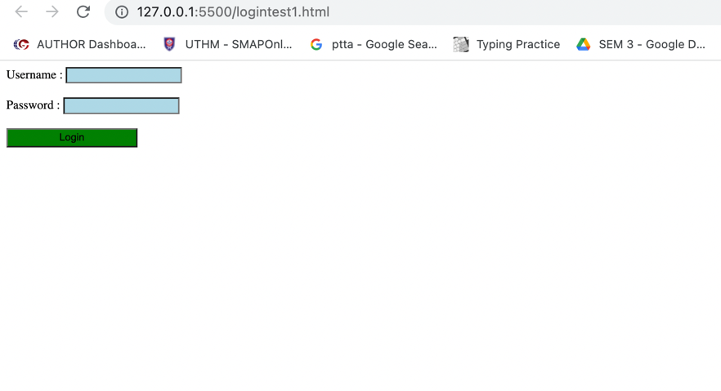

**ii)**

# **Q3**

a)

<!DOCTYPE html>

<html>

<head>

<title>Currency Converter</title>

<link rel="stylesheet" href="https://cdnjs.cloudflare.com/ajax/libs/materialize/1.0.0/css/materialize.min.css">

</head>

<body>

<div class="container">

<div class="row">

<div class="col l6 m6 s6">

</div>

<div class="col l5 m6 s12 ">

<div class="card-panel z-depth-4">

<form>

<t><h4>Currency Converter</h4></t>

<label for="colFormLabelSm">USD</label>

<input type="number" id="forex-amount" placeholder="Enter Amount">

<br> <br>

<label for="colFormLabelSm">USD</label>

<select id="forex-rate" name="rate">

<option disabled value="select" selected>select currency</option>

<option value="4.47">USD</option>

</select>

<br> <br>

<label for="colFormLabelSm">MYR</label>

<input type="text" placeholder="Amount In UGX" id="forex-ugx">

</form>

</div>

</div>

</div>

</div>

<script src="https://cdnjs.cloudflare.com/ajax/libs/materialize/1.0.0/js/materialize.min.js"></script>

<script>

document.addEventListener('DOMContentLoaded', function() {

document.getElementById("forex-amount").addEventListener("input",calculator);

document.getElementById("forex-rate").addEventListener("change",ChangeCurreny);

function calculator(){

let amount = document.getElementById("forex-amount").value;

let rate = document.getElementById("forex-rate").value;

if(rate == "select"){

document.getElementById("forex-ugx").setAttribute("placeholder","please select currency");

}else{

let compute = amount * rate;

document.getElementById("forex-ugx").value = compute;

}

}

function ChangeCurreny(){

let rate = document.getElementById("forex-rate").value;

let amount = document.getElementById("forex-amount").value;

let compute = rate * amount;

document.getElementById("forex-ugx").value = compute.toFixed(2);

}

let menu = document.querySelectorAll('select');

M.FormSelect.init(menu,{});

});

</script>

</body>

</html>

b) <!DOCTYPE html>

<html>

<style>

table, th, td {

border:1px solid black;

text-align: center;

border-collapse: collapse;

}

</style>

<body>

<?php

$cars = array(

array('Volvo' , '100' , 'Ahmad' ),

array('BMW' , '300' , 'Daniel' ),

array('Toyota' , '500' , 'John' ),

array('Proton' , '150' , 'Darren' ),

array('Perodua' , '50' , 'Lisa' ),

);

echo '<table border="1">';

echo '<tr>

<th>Car</th>

<th>Monthly Sales</th>

<th>Sales Executives</th>

</tr>';

foreach( $cars as $car )

{

echo '<tr>';

foreach( $car as $key )

{

echo '<td>'.$key.'</td>';

}

echo '</tr>';

}

echo '</table>';

?>

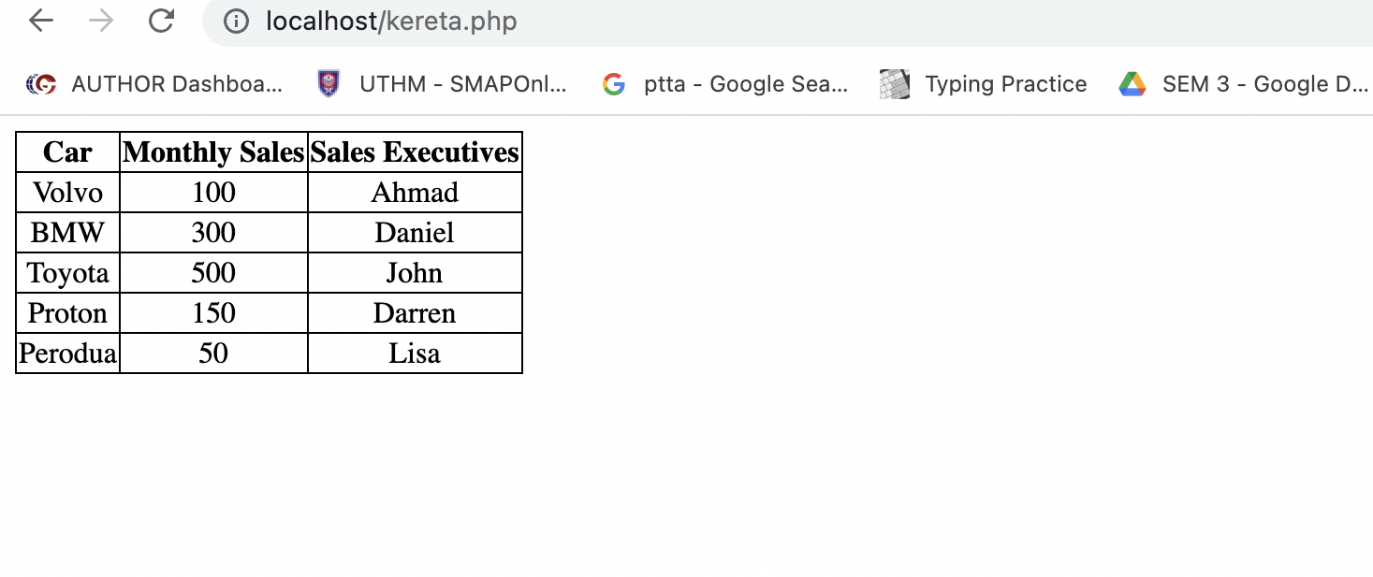

# **Q4**

(a)

(i)$Name's

Incorrect; no symbols other than "_" are allowed

(ii)$1Name

Incorrect ; starts with a number

(iii)$9

Incorrect ; starts with a number

B)

The connection can be lost or slowed down if too many distinct clients attempt to connect to the shared network at once. Any website or customer in the globe won't be able to access the information if the internet connection is unavailable.

C) <!DOCTYPE html>

<html lang="en">

<head>

<meta charset="UTF-8">

<meta name="viewport" content="width=device-width, initial-scale=1.0">

<title>Document</title>

<?php

echo ("f(even) = &nbsp;&nbsp;(");

$num1 = 1;

$num2 = 100;

for ($x = $num1; $x <= $num2; $x++) {

if ($x % 2 == 0) {

echo "$x";

}

}

?>

</head>

</html>

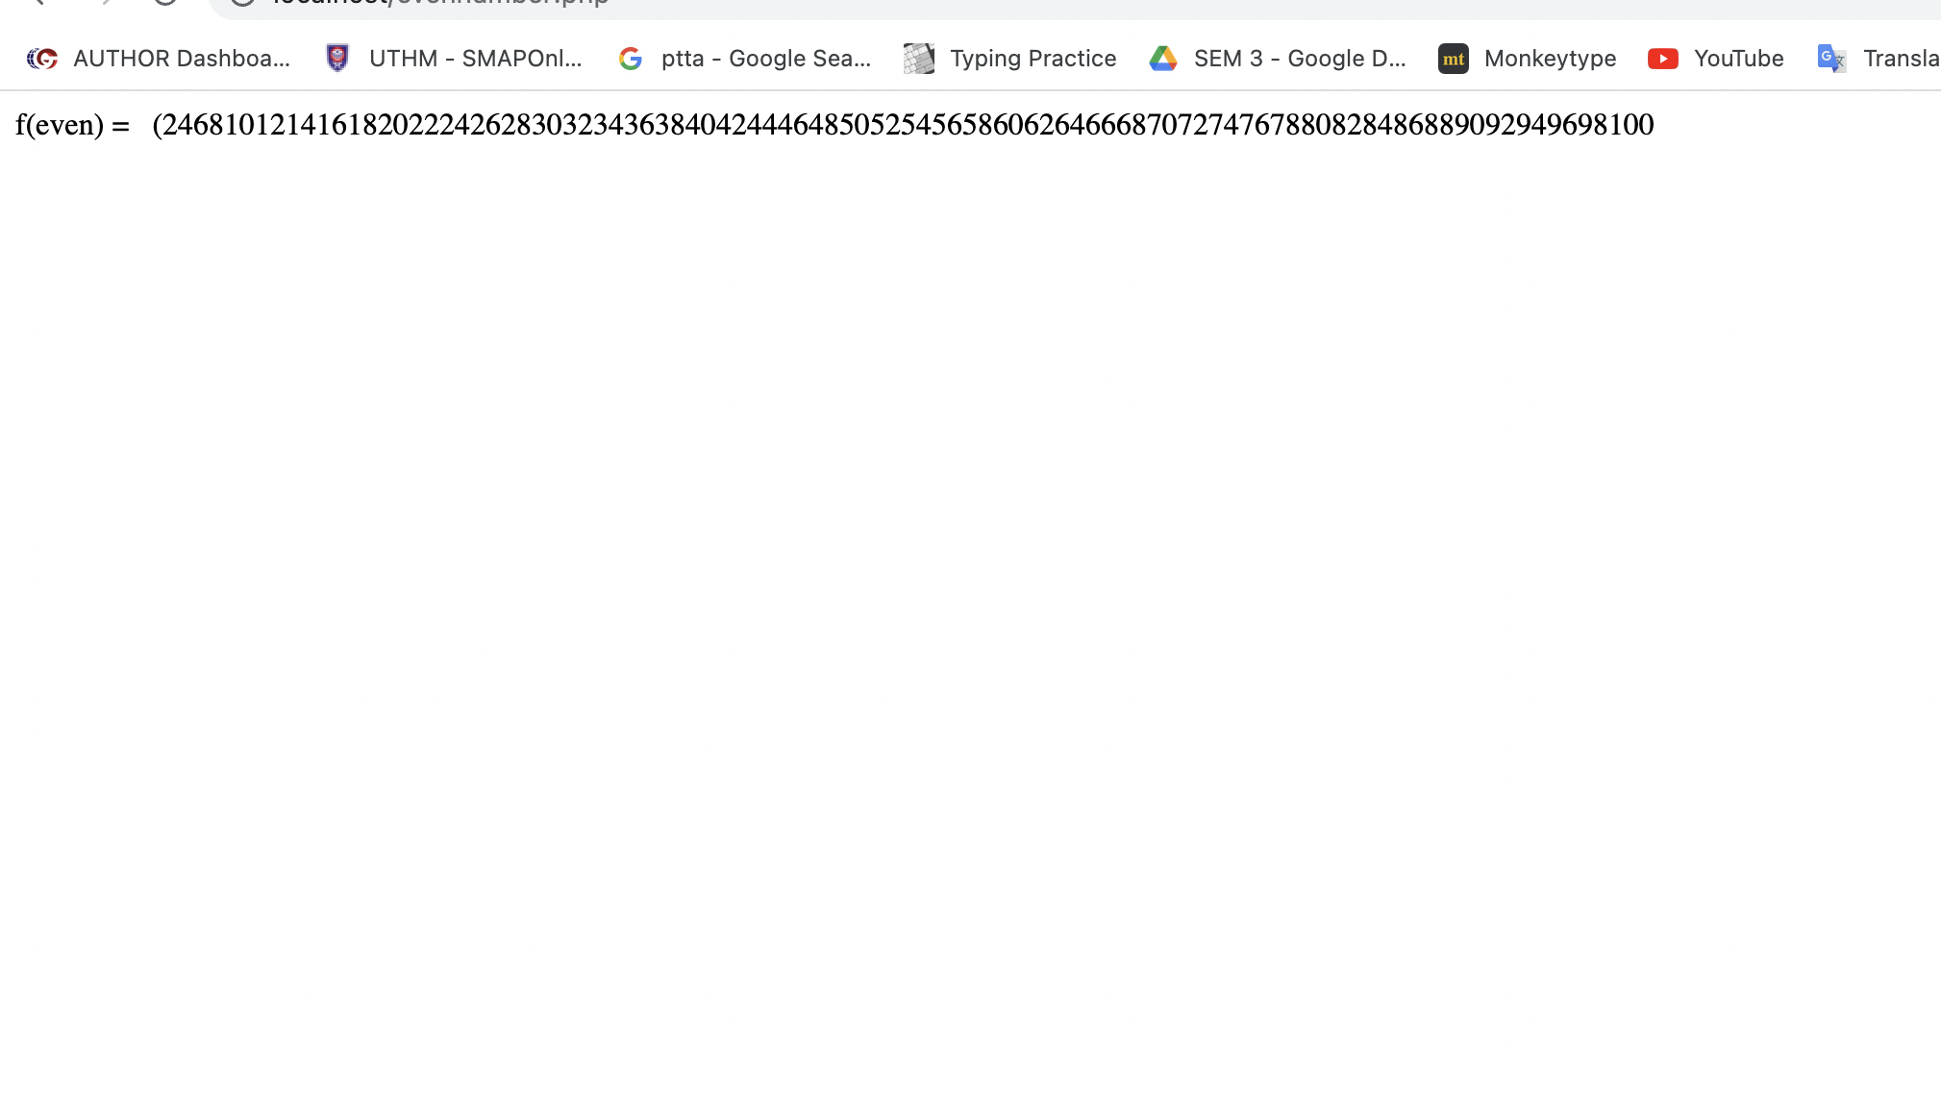

# **Q5**

i)

<!DOCTYPE html>

<html>

<head>

<style>

ul {

list-style-type: none;

margin: 0;

padding: 0;

overflow: hidden;

background-color: white;

}

li {

float: left;

}

li a {

display: block;

color: black;

text-align: center;

padding: 14px 16px;

text-decoration: none;

}

li a:hover {

background-color:grey;

}

body {

font-family: Arial;

margin: 0;

}

/* Header/Logo Title */

.header {

padding: 60px;

text-align: center;

background: rgb(151, 151, 151);

color: black;

font-size: 10px;

}

/* Page Content */

.content {padding:20px;}

div.gallery {

margin: 150px;

border: 1px solid #ccc;

float: left;

width: 180px;

}

div.gallery:hover {

border: 1px solid #777;

}

div.gallery img {

width: 100%;

height: auto;

}

div.desc {

padding: 15px;

text-align: center;

}

</style>

</head>

<body>

<ul>

<li><a class="active" href="#home">Home</a></li>

<li><a href="#Features">Features</a></li>

<li><a href="#Pricing">Pricing</a></li>

<li><a href="#disable">Disable</a></li>

</ul>

<div class="header">

<h1>Your Gadget Companion</h1>

<p>Resize this responsive page to the effect</p>

</div>

<div class="gallery">

<a target="_blank" href="razer.png">

<img src="razer.png" alt="Cinque Terre" width="600" height="400">

</a>

<div class="desc">Razer Mouse</div>

</div>

<div class="gallery">

<a target="_blank" href="logikeyboard.png">

<img src="logikeyboard.png" alt="Forest" width="600" height="400">

</a>

<div class="desc">LogiTech Gaming Keyboard</div>

</div>

<div class="gallery">

<a target="_blank" href="pcgaming.png">

<img src="pcgaming.png" alt="Northern Lights" width="600" height="400">

</a>

<div class="desc">Gaming PC</div>

</div>

<div class="gallery">

<a target="_blank" href="headphonegaming.png">

<img src="headphonegaming.png" alt="Mountains" width="600" height="400">

</a>

<div class="desc">Logitech Gaming Headset</div>

</div>

</div>

</body>

</html>

